DEVOPS INTERNSHIP REPORT
Phase 2: Core Concepts and Skills
Name: Your Name
Role: DevOps Intern
Company: yuva Intern

1. Introduction
This report covers Phase 2 of my DevOps internship, Core Concepts and Skills. In this phase I studied the theory behind essential DevOps practices and applied each concept through hands-on exercises and small projects. The work focused on Linux, Git and GitHub, shell scripting, Docker, and CI/CD with GitHub Actions.

2. Objectives
- Understand the core concepts of DevOps and why best practices exist.
- Practice each concept through hands-on exercises.
- Build small projects that demonstrate individual skills.
- Follow industry best practices and avoid common mistakes.
- Evaluate my knowledge through self-assessment and mentor feedback.

3. Concepts and Skills Learned
Topic | What I learned
Linux basics | Navigating the file system, managing files, permissions with chmod, and checking processes with ps and top.
Git and GitHub | Branching, merging, pull requests, and resolving merge conflicts.
Networking basics | IP addresses, DNS, ports, HTTP/HTTPS, and connecting to servers with SSH.
Shell scripting | Writing Bash scripts with variables, loops, and conditions to automate tasks.
Docker | The difference between images and containers, writing a Dockerfile, building and running containers.
CI/CD | Automating builds and checks with GitHub Actions on every push.

4. Mini Projects

4.1 Bash System Info Script
I wrote a Bash script that prints the date, disk usage, and memory usage of the system. It shows how simple tasks can be automated from the command line.
#!/bin/bash
echo "Date: $(date)"
echo "Disk usage:"
df -h
echo "Memory:"
free -h

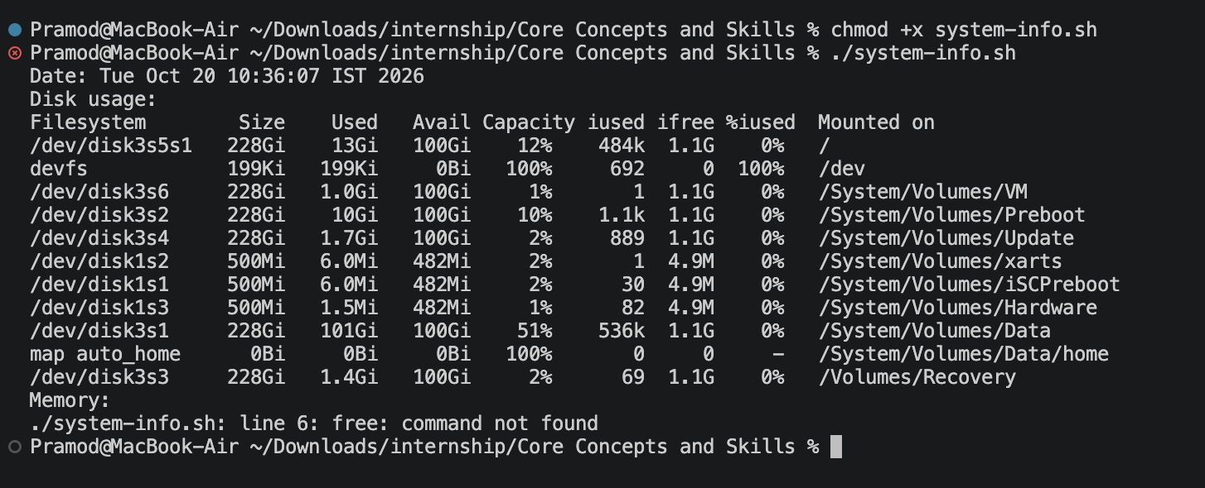
I made it executable with chmod +x system-info.sh and ran it with ./system-info.sh.
Figure 1: Output of the system info script
GitHub link: https://github.com/METEORBUZZ/internshipdevops/tree/main/Core%20Concepts%20and%20Skills

4.2 Dockerized Web Page
I created a simple HTML page and packaged it in a Docker image based on Nginx. I built the image, ran it as a container on port 8080, and opened it in the browser to confirm that it works.
FROM nginx:alpine
COPY index.html /usr/share/nginx/html/index.html
EXPOSE 80

docker build -t my-web-app .
docker run -d -p 8080:80 --name my-web-app-container my-web-app
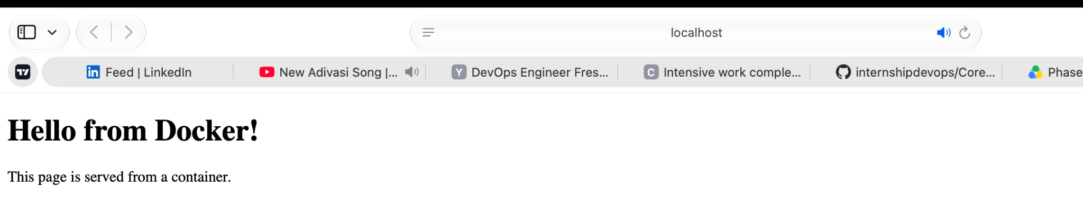
[
Figure 2: Web page served from the Docker container
GitHub link:
https://github.com/METEORBUZZ/internshipdevops/tree/main/Core%20Concepts%20and%20Skills

4.3 GitHub Actions CI Pipeline
I added a workflow file at .github/workflows/ci.yml. On every push and pull request, GitHub Actions checks out the code, runs the system info script, and builds the Docker image. A green tick shows that the pipeline passed.
name: CI
on:
push:
branches: [ main ]
pull_request:

jobs:
build:
runs-on: ubuntu-latest
defaults:
run:
working-directory: "Core Concepts and Skills"

steps:
- name: Checkout code
uses: actions/checkout@v4

- name: Run system info script
run: |
chmod +x system-info.sh
./system-info.sh

- name: Build Docker image
run: docker build -t my-web-app .
.
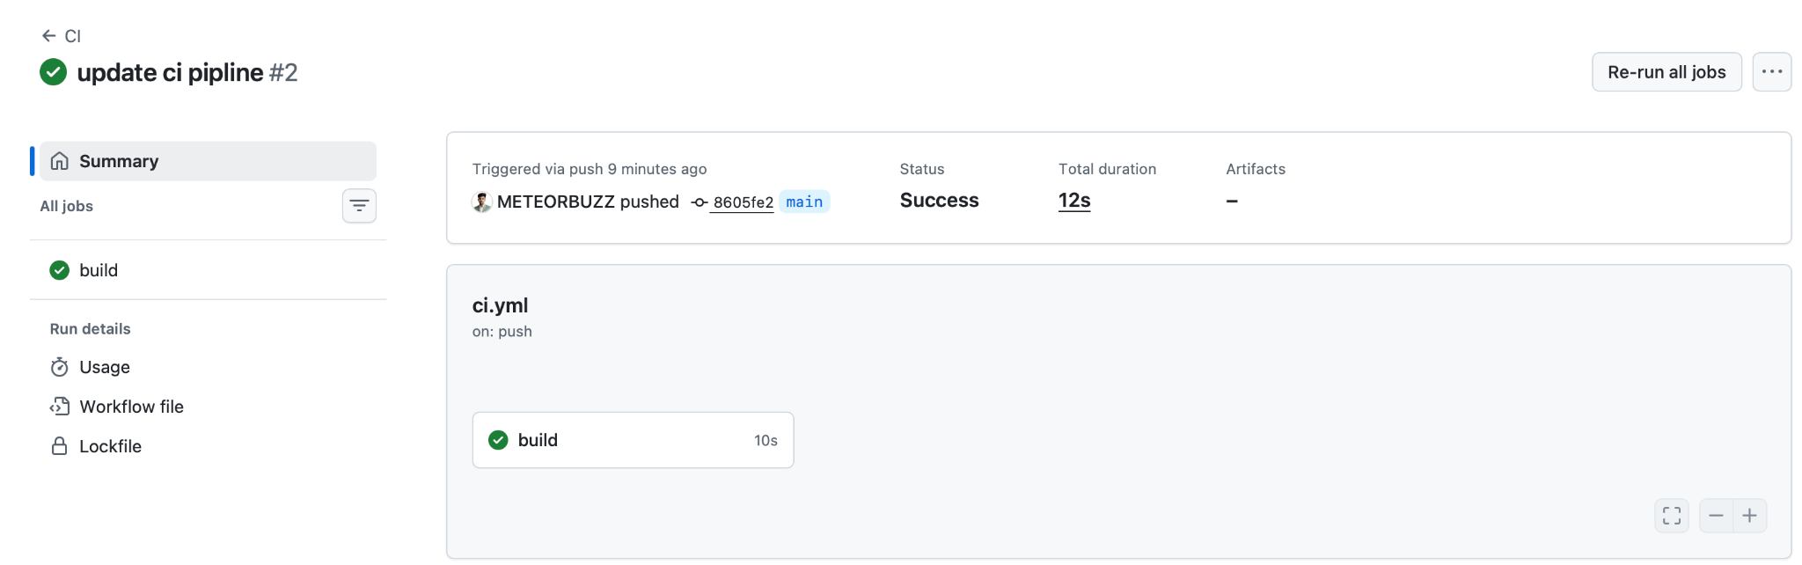
Figure 3: Successful CI pipeline run
GitHub link: https://github.com/METEORBUZZ/internshipdevops/actions/runs/39375182276

5. Best Practices Followed
- Used clear, lowercase file and folder names.
- Wrote small, meaningful commit messages.
- Kept all projects in version control on GitHub with a README.
- Never stored passwords or secret keys in the repository.
- Kept Docker images small by using the lightweight alpine base.

6. Common Pitfalls and How I Avoided Them
Pitfall | How to avoid it
Pushing secrets to GitHub | Keep secrets out of the repo and use GitHub Secrets instead.
Running everything as root | Use a normal user and sudo only when needed.
Bloated Docker images | Use small base images and copy only the required files.
Merging untested pipelines | Test the workflow on a branch first and read the logs.

7. Challenges and Solutions
Add a real difficulty you faced here, for example Docker not starting, a port already in use, or a failed GitHub Actions run, and explain how you solved it.

8. Self-Assessment and Mentor Feedback
Self-assessment: Write which topics you found easy and which need more practice.
Mentor feedback: Write the feedback your mentor gave you in the review sessions and what you will improve.

9. Learning Outcomes
- I can work comfortably in a Linux terminal and write simple Bash scripts.
- I understand how Docker containers work and can containerize a basic app.
- I can set up a CI pipeline with GitHub Actions.
- I follow version control and security best practices.

10. Conclusion
Phase 2 gave me practical experience with the core tools of DevOps. By building three small projects, I connected theory with practice and gained the confidence to take on more complex challenges in the next phase of my internship.

